Coat of Arms and site name implementation - CSS image replacement
The CUE template uses conditional comments and print styles to present different Coat of Arms versions in different situations.
Some versions of the Queensland Government Coat of Arms and site name will not display well in print. For example: where white text is used with transparency, it will be completely invisible when printed (background colours and background images are usually suppressed when printing).
To resolve this issue, three different versions of the Coat of Arms and site name are embedded in the HTML, the printable images, the 'on screen' transparent images and images for Internet Explorer 6.

For screen
Images to be used on screen are specified in the markup inside a downlevel-revealed conditional comment :
<a id="qg-coa" href="http://www.qld.gov.au/">
<!--[if gte IE 7]><!-->
<img src="theme/qg-coa.png" width="287" height="50"
alt="Queensland Government" />
<!--<![endif]-->
...
...
</a>

...

<h2 id="site-name"><a href="/">
<!--[if gte IE 7]><!-->
<img src="theme/site-name.png" height="28" alt="Site name" />
<!--<![endif]-->
...
...
</a></h2>
Which looks like this on screen:
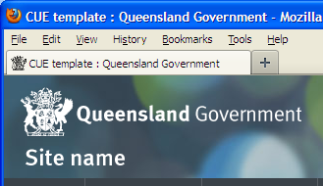

For screen (on Internet Explorer 6)
Internet Explorer 6 struggles with alpha transparency in images. So if alpha transparency was used for on screen images, you will need to provide alternative images that use index transparency using a downlevel-hidden conditional comment:
<a id="qg-coa" href="http://www.qld.gov.au/">
...
<!--[if lte IE 6]>
<img src="theme/qg-coa-ie6.png" width="287" height="50"
alt="Queensland Government" />
<![endif]-->
...
</a>

...

<h2 id="site-name"><a href="/">
...
<!--[if lte IE 6]>
<img src="theme/site-name-ie6.png" height="28" alt="Site name" />
<![endif]-->
...
</a></h2>

The images blended for index transparency look like this:

The end result looks like this in IE 6:
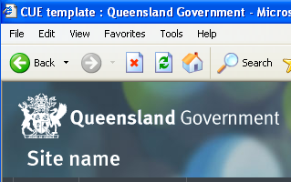

For print
Print images are then specified with a class of 'print-version' and an empty alt attribute:
<a id="qg-coa" href="http://www.qld.gov.au/">
...
...
<img src="cue/images/qg-coa-print.png" class="print-version" alt="" />
</a>

...

<h2 id="site-name"><a href="/">
...
...
<img src="theme/site-name-print.png" height="28" class="print-version" alt="" />
</a></h2>

Template print styles enable these versions of the images when printed:
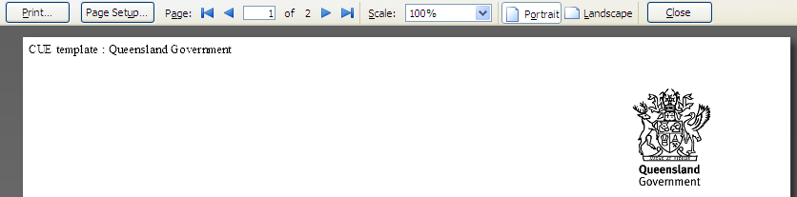

Complete markup
All together the markup looks like this:
<a id="qg-coa" href="http://www.qld.gov.au/">

<!--[if gte IE 7]><!-->
<img src="theme/qg-coa.png" width="287" height="50" alt="Queensland Government" />
<!--<![endif]-->

<!--[if lte IE 6]>
<img src="theme/qg-coa-ie6.png" width="287" height="50" alt="Queensland Government" />
<![endif]-->

<img src="cue/images/qg-coa-print.png" class="print-version" alt="" />
</a>

...

<h2 id="site-name"><a href="/">
<!--[if gte IE 7]><!-->
<img src="theme/site-name.png" height="28" alt="Site name" />
<!--<![endif]-->

<!--[if lte IE 6]>
<img src="theme/site-name-ie6.png" height="28" alt="Site name" /><![endif]-->

<img src="theme/site-name-print.png" height="28" class="print-version" alt="" />
</a></h2>

Discussion
The benefits of this approach are:
- Appropriate images served for modern browsers, IE6 and for printing
- Alt text is visible when images are disabled in all browsers
- Site name image width does not need to be specified in HTML or CSS
Some drawbacks of this approach are:
- Complex markup (can be simplified when full support is dropped for IE6)
- Both screen and print images are visible if styles are disabled (very rare edge case and document is still usable)
This approach was deemed the most suitable approach and can be simplified once IE6 is moved from the CUE full support browser list.

Other approaches considered
CSS image replacement was considered as a solution for presenting different images in different situations.
This approach was rejected due to the following drawbacks:
- Complex CSS (image replacements in multiple files and site name image width must be specified in CSS)
- Alt text is only visible when images are disabled in Gecko browsers (all other browsers see nothing)
